Assignment 7
Rollback and Commit commands Create Teacher table with the following fields (Name, DeptNo, Date of joining, DeptName, Location, Salary)
( a ) Insert five records
( b ) Give Increment of 25% salary for Mathematics Department . ( c ) Perform Rollback command (d)GiveIncrementof15%salaryforCommerce Department
( e ) Perform commit command
Code:
CREATE DATABASE CollegeDB;
USE CollegeDB;
CREATE TABLE Teacher (
Name VARCHAR(50),
DeptNo INT,
Date_of_Joining DATE,
DeptName VARCHAR(50),
Location VARCHAR(50),
Salary DECIMAL(10,2)
);
INSERT INTO Teacher VALUES
('Utsah', 101, '2018-06-12', 'Mathematics', 'Delhi', 50000),
('Utsav', 102, '2019-07-10', 'Commerce', 'Mumbai', 45000),
('Dipesh', 103, '2017-03-15', 'Mathematics', 'Delhi', 55000),
('Mahkar', 104, '2020-01-20', 'Commerce', 'Kolkata', 40000),
('Aryaveer', 105, '2016-09-05', 'Science', 'Chennai', 60000);
START TRANSACTION;
SET SQL_SAFE_UPDATES = 0;
UPDATE Teacher
SET Salary = Salary + (Salary * 0.25)
WHERE DeptName = 'Mathematics';
ROLLBACK;
UPDATE Teacher
SET Salary = Salary + (Salary * 0.15)
WHERE DeptName = 'Commerce';
COMMIT;
select * from teacher;
OUTPUT:
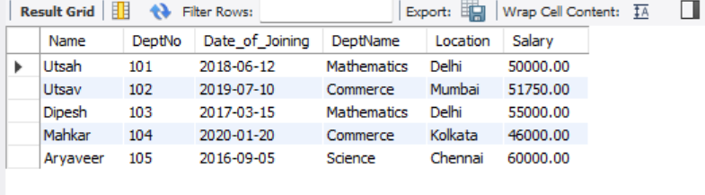
Assignment 8
(Exercise on order by and group by clauses) Create Sales table with the following fields ( Sales No, Salesname, Branch, Salesamount, DOB)
( a ) Insert five records
( b ) Calculate total salesamount in each branch
( c ) Calculate average salesamount in each branch ( d ) Display all the salesmen, DOB who are born in the month of December as day in character format i.e. 21-Dec-09
( e ) Display the name and DOB of salesman in alphabetical order of the month.
CODE:
CREATE DATABASE SalesDB;
USE SalesDB;

CREATE TABLE Sales (
SalesNo INT,
Salesname VARCHAR(50),
Branch VARCHAR(50),
Salesamount DECIMAL(10,2),
DOB DATE
);
INSERT INTO Sales VALUES
(1, 'Utsah', 'Lucknow', 50000, '1999-12-21'),
(2, 'Neha', 'Mumbai', 60000, '1998-05-15'),
(3, 'Ravi', 'Delhi', 55000, '2000-12-10'),
(4, 'Dipesh', 'Kolkata', 45000, '1997-08-25'),
(5, 'Mahkar', 'Mumbai', 70000, '1996-12-05');
SELECT Branch, SUM(Salesamount) AS Total_Sales
FROM Sales
GROUP BY Branch;
SELECT Branch, AVG(Salesamount) AS Average_Sales
FROM Sales
GROUP BY Branch;
SELECT Salesname, DATE_FORMAT(DOB, '%d-%b-%y') AS Formatted_DOB
FROM Sales
WHERE MONTH(DOB) = 12;
SELECT Salesname, DOB
FROM Sales
ORDER BY Salesname ASC;
OUTPUT: 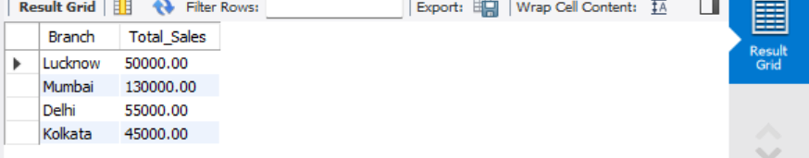
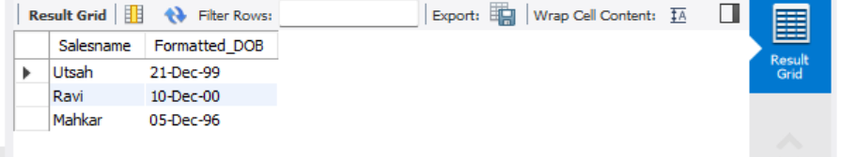

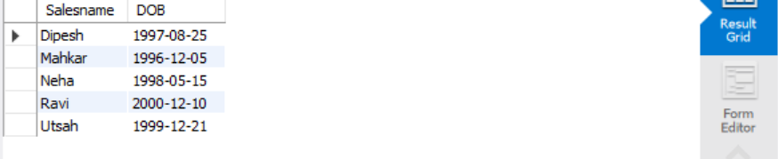
Assignment 9
Consider the following tables namely “DEPARTMENTS” and “EMPLOYEES” Their schemas
are as follows,
Departments ( dept no , dept name , dept_location ); Employees ( emp_id , emp_name , emp_salary,dept_no);
a) Develop a query to grant all privileges of employees table into departments table
b) Develop a query to grant some privileges of employees table into departments table
c) Develop a query to revoke all privileges of employees table from departments table
d) Develop a query to revoke some privileges of employees table from departments table
e) Write a query to implement the save point.
CODE:
CREATE DATABASE CompanyDB;
USE CompanyDB;
CREATE TABLE Departments (
dept_no INT PRIMARY KEY,
dept_name VARCHAR(50),
dept_location VARCHAR(50)
);

CREATE TABLE Employees (
emp_id INT PRIMARY KEY,
emp_name VARCHAR(50),
emp_salary DECIMAL(10,2),
dept_no INT
);
INSERT INTO Departments VALUES
(101, 'HR', 'Delhi'),
(102, 'IT', 'Mumbai');

INSERT INTO Employees VALUES
(1, 'Utsah', 50000, 101),
(2, 'Dhruv', 60000, 102);
CREATE USER 'user1'@'localhost' IDENTIFIED BY '1234';
GRANT ALL PRIVILEGES ON CompanyDB.Employees TO 'user1'@'localhost';
GRANT SELECT, INSERT ON CompanyDB.Employees TO 'user1'@'localhost';
REVOKE ALL ON CompanyDB.Employees FROM 'user1'@'localhost';
SHOW GRANTS FOR 'user1'@'localhost';
GRANT INSERT ON CompanyDB.Employees TO 'user1'@'localhost';
REVOKE INSERT ON CompanyDB.Employees FROM 'user1'@'localhost';
START TRANSACTION;

SAVEPOINT sp1;

UPDATE Employees
SET emp_salary = emp_salary + 5000
WHERE dept_no = 101;

ROLLBACK TO sp1;

COMMIT;
OUTPUT: 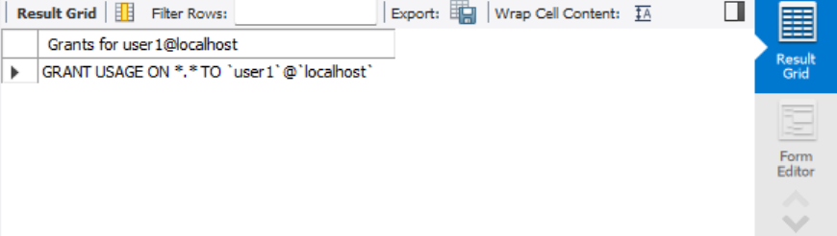
Assignment 10
Using the tables “DEPARTMENTS” and “EMPLOYEES” perform the following queries
a) Display the employee details, departments that the departments are same in both the emp and dept.
b) Display the employee name and Department name by implementing a left outer join.
c) Display the employee name and Department name by implementing a right outer join.
d) Display the details of those who draw the salary greater than the average salary
CODE:
CREATE DATABASE CompanyDAB;
USE CompanyDAB;
CREATE TABLE Departments (
dept_no INT PRIMARY KEY,
dept_name VARCHAR(50),
dept_location VARCHAR(50)
);

CREATE TABLE Employees (
emp_id INT PRIMARY KEY,
emp_name VARCHAR(50),
emp_salary DECIMAL(10,2),
dept_no INT,
FOREIGN KEY (dept_no) REFERENCES Departments(dept_no)
);
INSERT INTO Departments VALUES
(101, 'HR', 'Delhi'),
(102, 'IT', 'Mumbai'),
(103, 'Finance', 'Chennai'),
(104, 'Marketing', 'Kolkata');

INSERT INTO Employees VALUES
(1, 'Utsah', 50000, 101),
(2, 'Utsav', 60000, 102),
(3, 'Ravi', 55000, 101),
(5, 'Anil', 70000, 102);
SELECT *
FROM Employees E
INNER JOIN Departments D
ON E.dept_no = D.dept_no;
SELECT E.emp_name, D.dept_name
FROM Employees E
LEFT JOIN Departments D
ON E.dept_no = D.dept_no;
SELECT E.emp_name, D.dept_name
FROM Employees E
RIGHT JOIN Departments D
ON E.dept_no = D.dept_no;
SELECT emp_name, emp_salary
FROM Employees
WHERE emp_salary > (
SELECT AVG(emp_salary) FROM Employees
);
OUTPUT:
